- A RECTANGLE has four sides; opposite sides of a rectangle are equal and parallel to each other.
- The measure of each of its interior angle is 90°.
- It has 2 diagonals that bisect each other.

- A regular NANOGON is a nine-sided shape with equal sides and equal angles.
- The measure of each of its interior angle is140°.
- It has 27 diagonals.
- A REGULAR PENTAGON is a five-sided shape with equal sides and equal angles.
- The sum of all interior angles is equal to 540°.
- In a regular pentagon, each interior angle measures 108°, and exterior angle measures 72°.

- A REGULAR OCTAGON is an eight-sided shape with equal sides and equal angles.
- The sum of all the interior angles is 1080° and each angle measures 135°.
- The sum of all the exterior angles is 360° and each angle measures 45°.
- It has 20 diagonals.
- A regular HEPTAGON is a seven-sided shape with equal sides and equal angles.
- The sum of all interior angles is 900°; each interior angle measures about 128.57°.
- The sum of all exterior angles is 360°.
- It has 9 diagonals.

- A regular HEXAGON is a six-sided shape with equal sides and equal angles.
- The sum of all interior angles is 720°; each interior angle measures 120°.
- The sum of all exterior angles is 360°; each exterior angle measures 60°.
- It has 9 diagonals.
- A SQUARE has four equal sides and opposite sides are parallel to each other.
- The measure of each of its interior angle is 90°.
- It has 2 diagonals that bisect each other perpendicularly.
- A REGULAR DECAGON has 10 equal-length sides and equal-measure interior angles.
- Each angle measures 144° and they all add up to 1,440°.

EQUILATERAL TRIANGLE:
- Three sides are of the same length.
- Three angles are also equal.
- Each interior angle measures 60°.

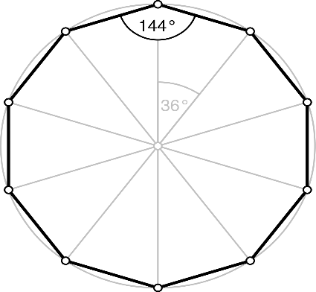

THREE-SIDED POLYGON |  | FOUR-SIDED POLYGON
FIVE-SIDED POLYGON |  | SIX-SIDED POLYGON
SEVEN-SIDED POLYGON |  | EIGHT-SIDED POLYGON
NINE-SIDED POLYGON |  | TEN-SIDED POLYGON
EQUILATERAL TRIANGLE |  | ISOSCELES TRIANGLE
RIGHT-ANGLE TRIANGLE |  | ACUTE-ANGLE TRIANGLE
OBTUSE-ANGLE TRIANGLE |  | SCALENE TRIANGLE
POLYGONS | TRIANGLE |  | PENTAGON
QUADRILATERAL | HEXAGON |  | SEPTAGON
HECTAGON | NANOGON |  | DECAGON
SQUARE | RECTANGLE |  | TRAPEZIUM
RHOMBUS | PARELLELOGRAM |  | KITE
In an obtuse-angle triangle:
- One of the angle measures more than 90°.

- A TRAPEZIUM is a quadrilateral where only one pair of opposite sides are parallel to each other.
- If the non-parallel sides are equal, then it is known as an isosceles trapezium.

- A RHOMBUS is a four-sided shape.
- All sides are equal and, opposite sides are parallel to each other.
- Opposite angles are equal.
- Sum of any two adjacent angles is 180°.

- A KITE is a four-sided shape.
- Two pairs of sides known as consecutive sides are equal in length.
- One pair of diagonally opposite angles is equal in measurement.
- The diagonals meet each other at 90°.
ACUTE-ANGLE TRIANGLE:
- All the angles are acute angles.

RIGHT-ANGLE TRIANGLE:
- One of the angle is 90°.
- The other two angles are acute angles.
- The side opposite to the right angle is the largest side of the triangle and is called hypotenuse.

ISOSCELES TRIANGLE:
- Two sides are of the same length and the third side is of a different length.
- The interior angles opposite to the equal sides measure the same.

SCALENE TRIANGLE:
- All the three sides are of the different length.
- All the interior angles are of different measure.

- A PARALLELOGRAM is a four-sided shape.
- Opposite sides are equal and parallel to each other.
- Opposite angles are equal.
- Sum of any two adjacent angles is 180°.
- It has 2 diagonals that bisect each other.

OBTUSE-ANGLE TRIANGLE:
- Any one of the interior angles is an obtuse angle (more than 90°).
- The side opposite to the obtuse angle is the longest side of the triangle.

OF POLYGONS
CONCEPT MAP

